Explaining Enterococci

“Hi everyone, welcome to the IDIOTS podcast, that’s Infectious Disease Insight Of Two Specialists, I’m Jame, that’s Callum, and we’re going to tell you everything you need to know about Infectious disease, Callum how you doing?”

- What they are
- What they do
- How they’re classified
- How to kill them

What they are
- GPC – pairs, short chains
- Catalase neg
- Facultative Anaerobe
- Non-haemolytic
- Lancefield group D
- Historically classified alongside streptococci
  - now in a separate Family; Enterococcaceae (enterococci are the only genus that infect humans)
  - 500m years old!
- Located:
  - UGI tract
  - Biliary tract (Alkaline-resistant)

What they do:
NB: Opportunistically pathogenic, fairly indolent.
- UTI
- BSI
- Endocarditis
- SBP
- Meningitis (rare; complication of neuro device infection)

How they’re classified:
- 90-95%: E.faecalis
- 5%: E.faecium
- <1%: E. casseliflavus, E. gallinarum, and E. raffinosus

How to kill them
- Intrinsically resistant:
  - Cephalosporins
  - Carbapenems
  - Aminoglycosides
  - Quinolones
- Amoxicillin:
  - E.faecaliS = Sensitive, E.faeciuM = Must use another antibiotic!
- Nitrofurantoin for UTIs
- IV:
  - Amoxicillin if possible (EFLIS)
  - Vancomycin
    - Binds D-Ala-D-Ala in peptidoglycan precursor molecules precents cross-linkage
  - Other:
    - Daptomycin
    - Linezolid
    - Tigecycline
    - Quinupristin/dalfopristin (EFIUM) – Synercid;
      - streptogramin derivatives (protein synthesis inhibitors)
      - Bacteriostatic individually, cidal in combination
      - Dalfopristin binds 23S part of the 50S subunit changes conformation enhanced quinupristin binding 100x. Also inhibits peptidyl transfer.
      - Quinupristin binds a nearby site on 50S prevents elongation of the polypeptide.
  - Oral:
    - Amoxicillin (EFLIS)
    - Linezolid

AMR

Intrinsically resistant:
• Cephalosporins
• Carbapenems
• Aminoglycosides
• Quinolones
• Amoxicillin: faecaliS = Sensitive, E.faeciuM = Must use another antibiotic!

VRE Genes: encodes for peptidoglycan precursors with a different end-terminal, which would be crosslinked by PBPs:
Van-A: 1000x less binding affinity
All glycopeptides are useless
“A for aureus”; found in VRSA
Van-B: 1000x less binding affinity
Use your Backup glycopeptide: Teicoplanin (doesn’t induce VanB expression, whereas Vanc does)
Van-C: 7x less binding affinity

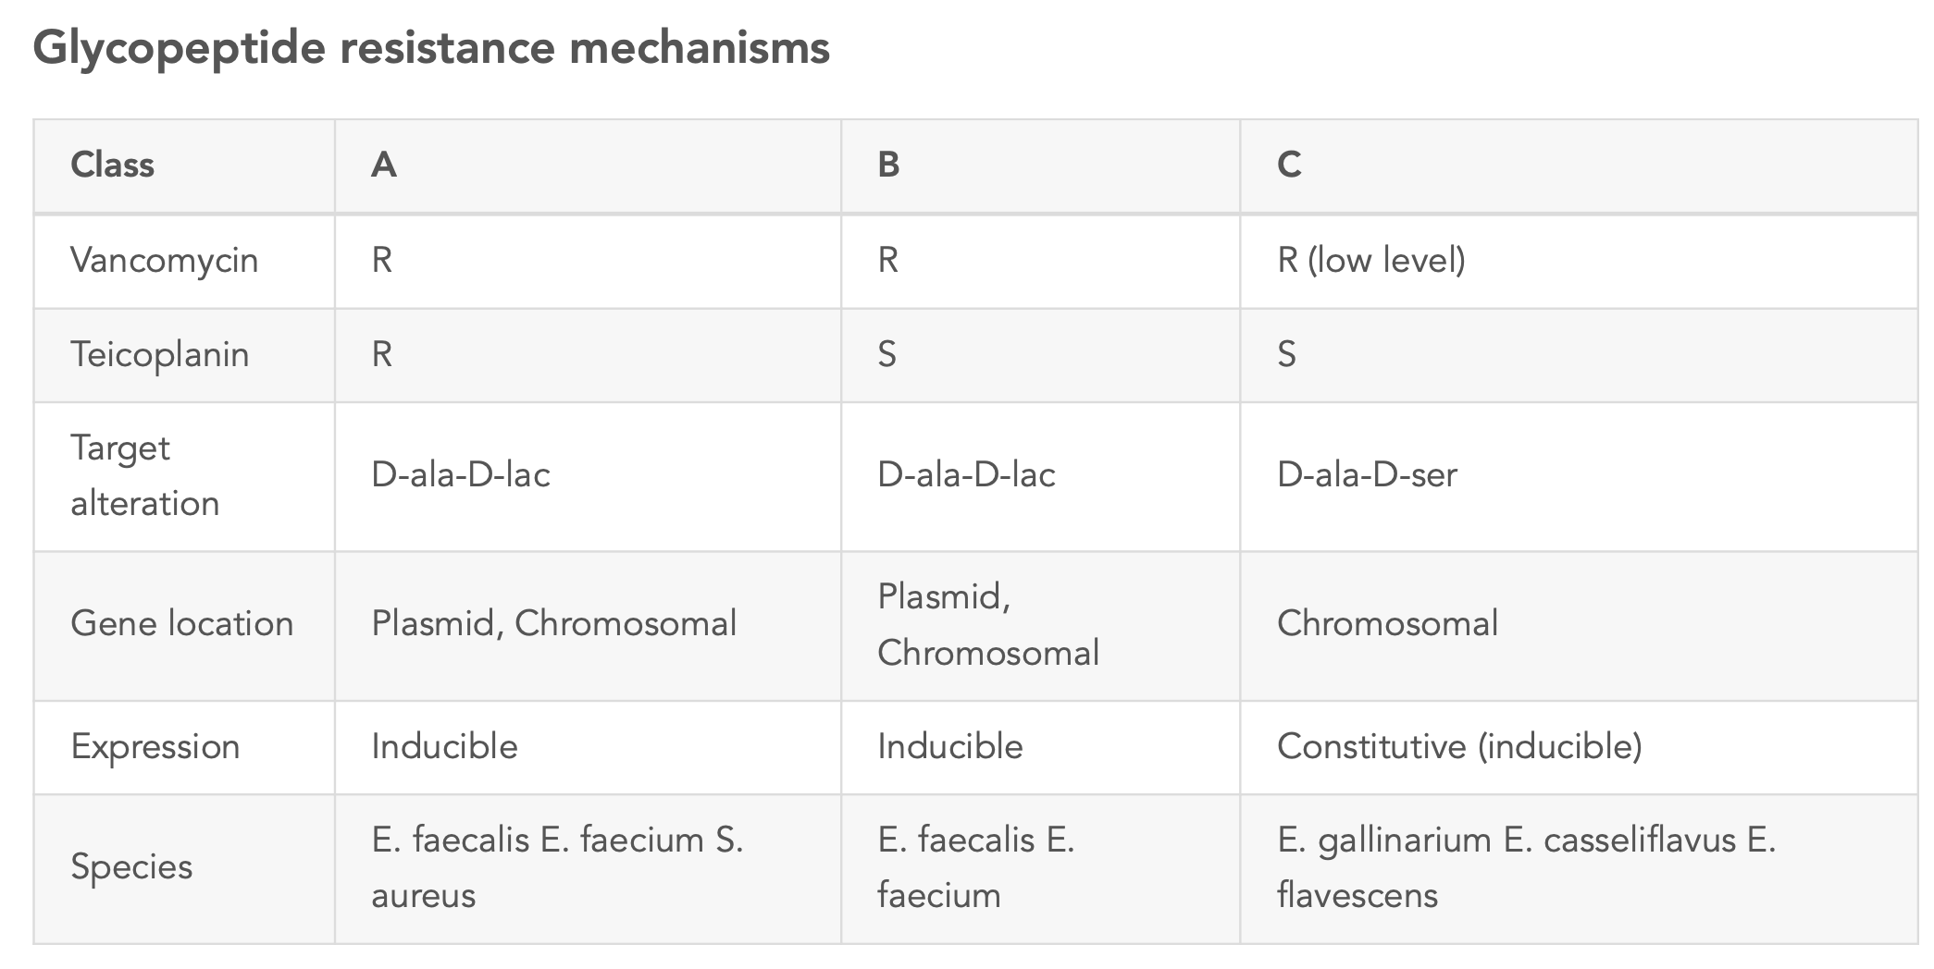

VanA/B move around via transposons; VanC is species-specific

