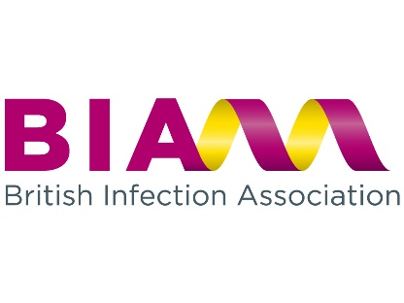
BIA EXPENSES CLAIM FORM

- Claims should be made within 2 months of the date of the event.
- Claims must be reasonable, as economical as possible, and supported by receipts.
- The following have been agreed as suitable for BIA expense claims:

- BIA meeting attendance: travel to and from face to face meetings, and one night’s accommodation (max £175). Travel should be as economical as possible and preferably booked in advance to obtain the best rates. Advance first class tickets for journeys longer than 2 hours may be reimbursed if they are cheaper than a standard economy ticket bought at the same time/day of travel. Meetings include: Council Meetings, Clinical Services Meetings, and other meetings where BIA representation is required.
- Chairs and speakers for BIA conferences: complementary conference registration.
- Other: at the discretion of Council with prior agreement.

Name:……………………………………………………………………………………………..

Address:…………………………………………………………………………………………..

Bank Account sort code ………………. Bank Account Number ……………....................

Claim details (please indicate) | Event Date | x
Society meeting representation
BIA council meeting attendance
Clinical services meeting attendance
Other (please specify)

Expenses details:
Travel | Air | £
 | Rail | £
 | Taxi | £
 | Car | £
 | Car Parking | £
 | Mileage @ 56p per mile | £
 | Other | £
 | Sub total | £
Accommodation | Hotel (max £175 per night) | £
 | Total claim amount | £

Signature: ………………………………….. ………………… Date: ……………………….

Laura Smith laura@hartleytaylor.co.uk
Hartley Taylor Ltd, 2a St George’s Court, St George’s Park, Kirkham, Preston, PR4 2EF

